MSC Inventory Sync (4.0)

Author: <Radhika>

Creation Date: May 29, 2021

Last Updated: May 29, 2021

Document Ref: <D>

Version: 1

1. **Title, Subject, Last Updated Date, Reference Number**, **and** **Version** are marked by a Word Bookmark so that they can be easily reproduced in the header and footer of documents. When you change any of these values, be careful not to accidentally delete the bookmark. **You can make bookmarks visible by selecting the Office Button>Word Options>Advanced> and checking the Show bookmarks option in the Show document content region.**

**Approvals:**

|  |  |
| --- | --- |
| <Approver 1> |  |
| <Approver 2> |  |

1. To add additional approval lines, press [Tab] from the last cell in the table above.

oracle.gif

1. You can delete any elements of this cover page that you do not need for your document.

# Document Control

## Change Record

5

| Date | Author | Version | Change Reference |
| --- | --- | --- | --- |
| 29-May-21 | <Radhika thipparthi> |  | No Previous Document |
|  |  |  |  |
|  |  |  |  |
|  |  |  |  |

## Reviewers

| Name | Position |
| --- | --- |
|  |  |
|  |  |
|  |  |
|  |  |

Contents

1 Document Control ii

1.1 Change Record ii

1.2 Reviewers ii

2 Technical Overview 1

2.1 Building Blocks 1

2.2 Block Relationship Diagram 1

3 Connections………………………………………………………………………..2

4. Interface Design 3

5 Open and Closed Issues 5

5.1 Open Issues 5

5.2 Closed Issues 5

1. To update the table of contents, put the cursor anywhere in the table and press [F9]. To change the number of levels displayed, select the menu option Insert‑>Index and Tables, make sure the Table of Contents tab is active, and change the Number of Levels to a new value.

# Technical Overview

1. The purpose of this task is to assemble all the information that is required to describe the design of a software component into a complete Design Specification. This task is not a substitute for executing the individual design tasks. This specification work product can serve as a structure for completing the design for each component by providing pointers back into the Design Tasks:   
   - DS.040 Develop Design Architecture Description  
   - DS.080 Design Software Components  
   - DS.090 Design Data  
   - DS.100 Design Behavior  
   - DS.130 Design User Interface

This Design Specification documents detailed design for Oracle fusion Cloud(OFC) to Oracle Commerce Cloud(OCC) Customer Credit Limit interface.

* Oracle Fusion Cloud application is used to getting Credit files from ERP and this data is interfaced to Oracle Commerce Cloud to upload credit limit for the customer. To achieve this, Integration needs to be established between ERP and Cloud Commerce for update the credit limit
* This interface is used to updates the Credit limit for the Customer’s in OCC.

## Building Blocks

1. The intent of this section is to list the building blocks that are required to design the designated component. This includes classes, objects, modules, etc. Reference the Module View of the Architecture Description (RD.130) and appropriate Software Component Design (DS.080) to derive the list of classes and their relationships.

Building Blocks

* + OCC – Oracle Commerce Cloud
  + OIC – Oracle Integration Cloud
  + OFC – Oracle Fusion Cloud

## Block Relationship Diagram

1. The intent of this section is to graphically depict how the component under consideration interfaces to related components, external systems, and other actors that interact with the use-case package. Reference the Conceptual View and Module View of the Architecture Description (RD.130) and the class diagram prepared in the Software Component Design (DS.080) and Component Behavior Design (DS.100).

The diagram below represents the base tables of each block or zone of the form (vertical) and tables referenced for validation or lookups (horizontal).

Oracle Cloud

Commerce

Oracle

Integration

Cloud

Oracle

Fusion

Cloud

1. The intent of this section is to identify the table, columns, and source values that are required to support the above data elements. Refer to the Physical Database Design (IM.040), to identify the existing tables where the above attributes are located.
2. The intent of this section is to define the design considerations necessary to achieve the data retrieval and storage requirements for performance. Include performance requirements as specified in the Supplemental Requirements (RD.055) for service level requirements (i.e., 1-minute response time, etc.)
3. The intent of this section is to define the implementation strategy for each business rule within this component. Refer to the DS.110 Business Rules Design to capture the Business Rules for this component.

# CONNECTION

# Interface Design

1. The intent of this section is to design the services between the components and the interfaces with external systems for each Use Case. Refer to DS.080 Software Component Design and focus on calling arguments (i.e., service signature) and logic definition.

Overview description: Interface is Scheduled based interface.

Step1: List input files from **/home/OCC/Inventory** by using FTP adapter and configure as below.

* Enter the name 🡪 ListInputFiles.
* Basic Info 🡪 Enter endpoint name.

Step2: For each file,

Download file by using FTP Adapter.

Step 3: Read each inventory file by using Stage file.

Step 4: For each inventory file,

Scope of the items(Default handler)

* Update inventory file by using OCC adapter.

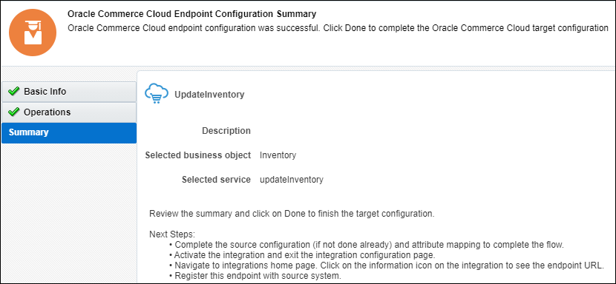

* Write error file by using FTP Adapter.

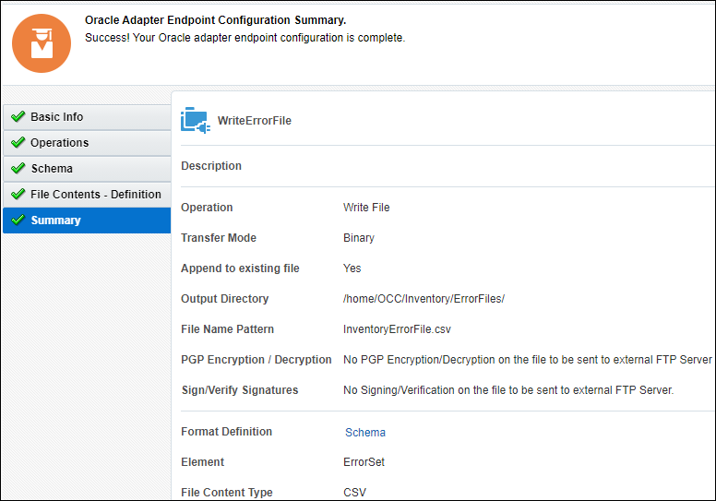

Scope ends here. For loop ends here.(For each file).

Step 5: Move each file to archive directory **/home/OCC/Inventory/Archive/** by using FTP Adapter..

For each Inventory file loop ends here.

Step6: Check 2 conditions.

1. Check if $P_Flag=’Y’, then run the integration(Send OCC Invontory Error report) to send error report to the team.

1. Otherwise, terminate the job.

# Open and Closed Issues

1. Add open issues that you identify while writing or reviewing this document to the open issues section. As you resolve issues, move them to the closed issues section and keep the issue ID the same. Include an explanation of the resolution.  
     
   When this work product is complete, any open issues should be transferred to the project- or process-level Issue Log (Manage focus area) and managed using a project level Issue Form (Manage focus area). In addition, the open items should remain in the open issues section of this work product, but flagged in the resolution column as being transferred.

## Open Issues

| ID | Issue | Resolution | Responsibility | Target Date | Impact Date |
| --- | --- | --- | --- | --- | --- |
|  |  |  |  |  |  |
|  |  |  |  |  |  |
|  |  |  |  |  |  |
|  |  |  |  |  |  |

## Closed Issues

| ID | Issue | Resolution | Responsibility | Target Date | Impact Date |
| --- | --- | --- | --- | --- | --- |
|  |  |  |  |  |  |
|  |  |  |  |  |  |
|  |  |  |  |  |  |
|  |  |  |  |  |  |

1. The intent of this section is to document the design changes necessary to provide archiving required to support this component. Refer to the Logical Database Design (DS.150).